1. Performance Benchmark
Design an iPerf test to compare: TCP throughput, UDP throughput
Explain:
- Differences observed
- Jitter
- Packet loss
- Retransmissions
- Practical recommendations
Step 1: Install iPerf using sudo apt install -y iperf3
Step 2: Check the version iperf3 –version
Step 3: In Terminal 1, start the iPerf3 process in server mode so it sits and listens for incoming traffic: iperf3 -s
Step 4: Switch over to Terminal 2. Run the TCP Test
iperf3 -c 127.0.0.1 -t 10 -i 1
Step 5: Switch over to Terminal 2. Run the UDP Test
iperf3 -c 127.0.0.1 -u -b 5G -t 10 -i 1
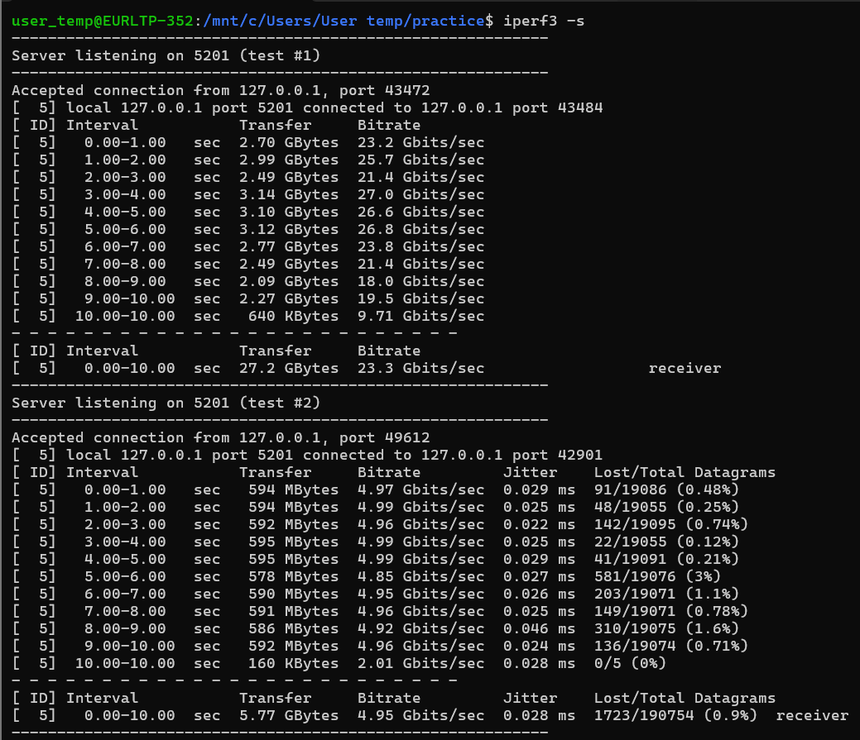
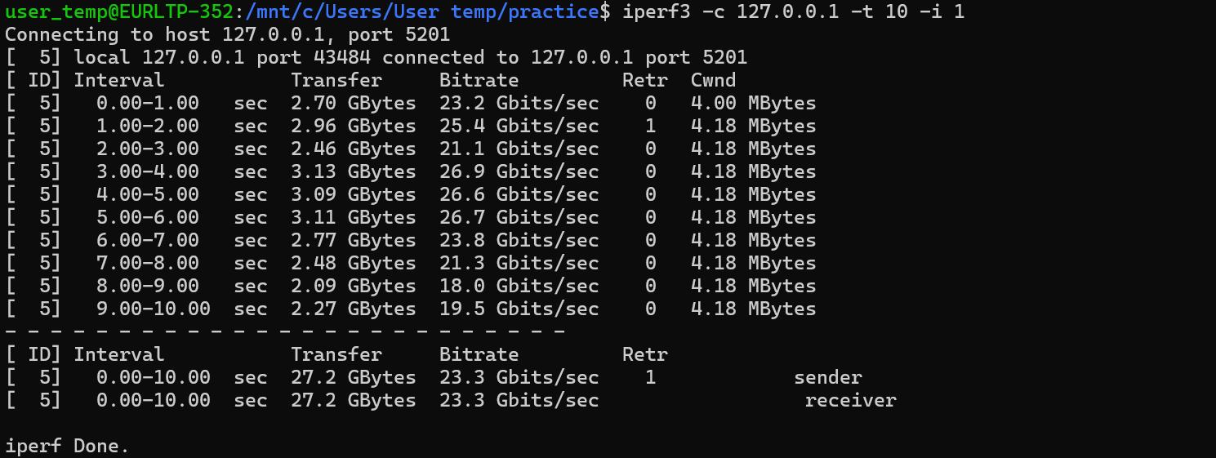
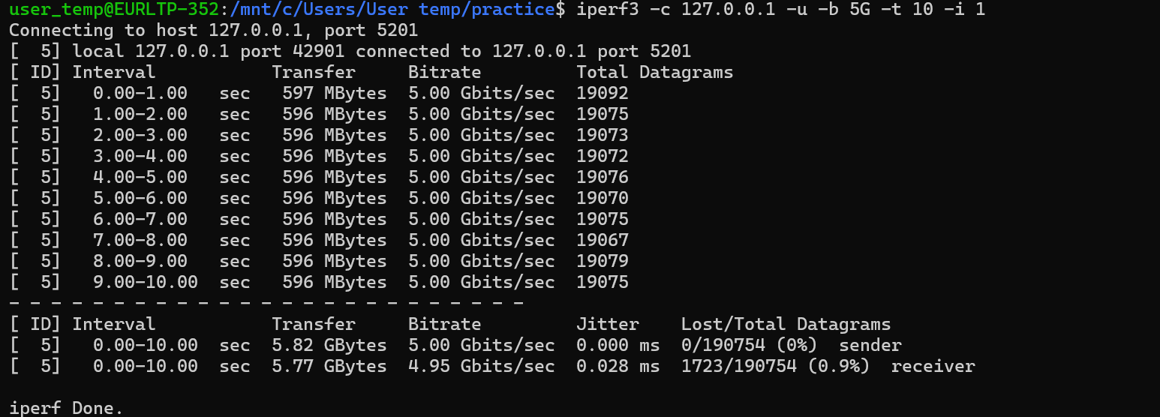
2 – Network Troubleshooting Scenario
A customer reports:
- Web pages load slowly.
- Video calls frequently freeze.
- File downloads are normal.
- CPU utilization on the server is below 30%.
You have access to:
- Wireshark
- TCPDump
- iPerf
Answer the following:
- Which tool would you use first and why?
- What information would you collect using each tool?
- What are three possible root causes?
- How would you conclude whether the issue is network-related or application-related?

1. Which tool would you use first and why?
Tool: iPerf
Reasoning: iPerf is the most efficient first step because it quickly establishes a baseline of the network's transport-layer health without requiring the deep, time-consuming analysis of millions of packets. The symptoms highlight a distinct split in protocol performance: bulk TCP traffic (file downloads) is succeeding, while real-time UDP traffic (video calls) and high-frequency TCP handshakes (web browsing) are failing. iPerf allows for the immediate generation of synthetic TCP and UDP traffic to confirm if the physical network pipeline is dropping packets or experiencing high latency, isolating the network layer before moving to packet capture.

2. What information would you collect using each tool?
- iPerf: I would run UDP bandwidth tests to collect packet loss percentage and jitter metrics (crucial for video freezing). I would also run TCP tests to monitor for TCP retransmissions and overall throughput capacity.
- TCPDump: I would use this command-line packet sniffer on the server interface to collect raw network traffic (.pcap files) exactly when the freezing or slowness occurs. It is lightweight and perfect for capturing data on a server without needing a graphical user interface.
- Wireshark: I would use Wireshark to perform Deep Packet Inspection (DPI) on the .pcap files generated by TCPDump. I would collect data on Time to First Byte (TTFB), look for TCP Window scaling issues, track TCP Retransmissions/Duplicate ACKs, and use the "RTP Stream Analysis" feature to locate exactly where video frames are dropping.

3. What are three possible root causes?
- High Network Jitter & Packet Loss: File downloads use TCP, which automatically hides network drops by retransmitting lost data (eventually pushing the file through). Video calls use UDP, which does not retransmit; when packets drop, the video freezes. Slow web pages require dozens of short TCP handshakes, and packet loss makes those round-trips painfully slow.
- Quality of Service (QoS) Misconfiguration: Network routers or firewalls may have traffic shaping rules applied that incorrectly prioritize bulk data transfers (FTP/HTTP downloads) while starving real-time RTP (video) traffic and DNS queries of necessary bandwidth.
- Slow DNS Resolution: If the DNS server is lagging, the browser takes a long time to resolve the IP address of the website, causing web pages to hang before loading. A file download only needs to resolve the DNS once; after the connection is established, the download continues at normal speed.

4. How would you conclude whether the issue is network-related or application-related?
This can be definitively concluded by analyzing the packet capture data in Wireshark:
- It is Network-related if: The capture shows a high number of TCP Retransmissions, Duplicate ACKs, out-of-order packets, or high Delta times (latency) at the transport layer between the client and the server.
- It is Application-related if: The initial network handshakes (TCP SYN, SYN-ACK, ACK) happen instantly with zero packet loss, but there is a massive delay before the server sends any actual HTTP payload data back (High TTFB). Because the server CPU is below 30%, this suggests the application is not struggling for raw processing power, but is instead bottlenecked waiting on a slow backend database query, a locked thread, or an unresponsive third-party API.
3.

4. Tool Selection
For each scenario below, identify the most appropriate tool and justify your choice.

Scenario | Recommended Tool | Reason
Measure TCP throughput between two hosts | iPerf (or iPerf3) | It is the industry standard for actively measuring maximum achievable bandwidth on IP networks. It uses a client-server model to easily generate pure TCP or UDP traffic and instantly reports throughput, packet loss, and retransmissions.
Capture packets from a Linux server | TCPDump | It is a lightweight, command-line packet analyzer native to Linux environments. It allows you to capture raw network traffic and save it to a .pcap file directly from the terminal, which is essential since most Linux servers do not have a graphical user interface (GUI) to run Wireshark.
Validate enterprise Wi-Fi performance | VeriWave (Keysight) | It is specialized hardware built specifically for wireless RF testing. It can simulate hundreds of virtual Wi-Fi clients connecting to a single Access Point simultaneously, allowing you to stress-test density, roaming, and 802.11 protocol compliance without needing hundreds of physical laptops in the lab.
Generate high-volume traffic | TRex (Cisco) | It is a DPDK-based traffic generator capable of pushing massive scale (Millions of Packets Per Second). It is designed to stress-test core network infrastructure like firewalls and enterprise routers by simulating heavy, stateful L4-L7 application traffic.

5: Enterprise Wireless Performance Validation [medium]
Scenario
You are working as a QA Automation Engineer in the Wireless Validation Team.
A new firmware image has been developed for the Cisco Catalyst 9800 Wireless Controller, and it must be validated before release.
The customer environment consists of:
- 1 Cisco Catalyst 9800 WLC
- 20 Access Points
- 1000 Wireless Clients
- VoIP Calls
- Video Conferencing
- File Downloads
- Web Browsing
You have access to the following tools:
- Wireshark
- Airtool
- Port Mirroring
- TCPDump
- TRex
- VeriWave
- iPerf
- Multicast Hammer Tool
- Octoscope
- IXIA – IXChariot
Submit:
- A Table that should list the purpose of each tool in the validation workflow and provide the exact conditions on which each tool must be used, referring to the customer environment.
Tool | Purpose in Validation Workflow | Exact Usage Conditions (Customer Environment Reference)
VeriWave | Simulates massive high-density wireless client behavior in a controlled environment to stress the WLC. | Must be used to simulate the 1000 Wireless Clients connecting simultaneously to the 20 Access Points, verifying the scaling limits and session management of the Cisco Catalyst 9800 WLC firmware without needing physical devices.
IXIA – IXChariot | Simulates and measures multi-protocol network application traffic to validate end-user Quality of Experience (QoE). | Must be used to generate stateful application layers mimicking the user environment: running concurrent VoIP Calls (measuring MOS/Jitter) and Video Conferencing streams across the simulated clients.
iPerf | Measures point-to-point peak TCP/UDP throughput and network layer capacity. | Must be used to baseline raw throughput and track packet loss during massive File Downloads across specific client sub-segments.
TRex | Generates high-volume, stateful L4–L7 background traffic at line rate on the wired backbone side. | Must be used on the wired distribution side of the Cisco 9800 WLC to stress-test data plane switching, tracking how processing high-volume Web Browsing sessions impacts the controller's CPU.
Octoscope | Provides an automated, isolated RF environment (anechoic chambers) to test roaming and attenuation cleanly. | Must be used to house a subset of physical Access Points and clients to evaluate seamless client roaming algorithms and signal degradation scenarios without external air space interference.
Multicast Hammer Tool | Blasts high-volume IP multicast streams to validate video delivery efficiency and multicast-to-unicast conversion mechanisms. | Must be used to validate the WLC's handling of enterprise-wide multicast traffic, ensuring that dense Video Conferencing or media broadcasts do not flood the wireless spectrum.
Airtool | Captures raw over-the-air (802.11) wireless frames directly from the radio frequency medium. | Must be used on the wireless side near the 20 Access Points to debug layer 2 Wi-Fi anomalies, management frames, or authentication failures during client connection bursts.
Port Mirroring | Replicates physical switch port traffic and forwards it to a monitoring device without disrupting production data. | Must be configured on the uplink switches connected directly to the Cisco 9800 WLC to mirror the aggregated network traffic for passive monitoring.
TCPDump | Captures raw packet data at the command-line interface level directly on the infrastructure elements. | Must be used directly on the wired infrastructure servers or the WLC shell to capture connection transactions during testing, saving data to .pcap files.
Wireshark | Performs deep packet analysis and graphical visualization of captured network traffic files. | Must be used to open and analyze the .pcap files extracted from TCPDump and Airtool to troubleshoot precise packet drops, high delta latency, or handshake issues during VoIP and Video freezes.

